Tasks

1.Visit any local retail store (like Reliance Fresh, D-Mart, or a neighborhood clothing shop) and list 5 in-store marketing techniques they use to attract customers (for example: product placement, discount boards, loyalty cards, sampling, or festive decorations).

2.Design a simple floor plan for a new sneaker store targeting Gen Z customers, showing where you would place best-selling products, offers, and checkout counters to maximize sales.<br><br><em><strong>Hint:</strong> Think about how Zomato or Flipkart highlight trending items on their homepages — apply similar logic to your store layout.</em>

3.Imagine you are launching a new soft drink in a college canteen. Write a short script (5-7 lines) for an in-store announcement or jingle that would grab the attention of students and encourage them to try your product.

4.Analyze the Instagram page of a popular retail brand (like H&M India, Decathlon, or Nykaa). Identify and describe 3 offline marketing events or campaigns they promoted recently (such as pop-up stores, in-store meetups, or festival sales) and explain how these events drive footfall to physical stores.

Answer:-

1. Local retail store observation
Store visited: D-Mart / Reliance Fresh / Local supermarket
Location: [Apne area ka naam likho]
Maine store mein ye 5 in-store marketing techniques notice ki:
No. | Marketing technique | Store mein kaise use hua | Customer par effect

No. | Marketing technique | Store mein kaise use hua | Customer par effect
1 | Product placement | Best-selling snacks, cold drinks, chocolates aur small impulse items checkout counter ke paas rakhe gaye the. | Billing ke time customer extra product add kar leta hai.
2 | Discount boards | “Buy 1 Get 1 Free”, “Flat 30% OFF”, “Weekend Offer” aur “Lowest Price” ke bright yellow/red boards lage the. | Large discount message immediately attention grab karta hai.
3 | End-cap displays | Aisle ke end par festive gift packs, cooking oil, biscuits ya special offers ka separate display tha. | Customer ko product easily dikh jata hai aur high-visibility milti hai.
4 | Loyalty card / membership | Store membership card ya mobile-number registration ke through points, special price aur discount offer kiya gaya. | Customer repeat shopping ke liye motivate hota hai.
5 | Festive decoration | Festival season ke according lights, themed posters, gift hampers aur festive colours use kiye gaye the. | Store festive aur attractive lagta hai; gifting aur impulse buying increase ho sakti hai.
Extra observation: Fruits, bakery aur fresh-food section ko entrance ke near rakhna bhi smart strategy hai. Fresh colours aur food smell customer ko store ke andar explore karne ke liye encourage karte hain.

2. Gen Z sneaker-store floor plan
Store name: KICKVERSE
Target audience: Gen Z students, sneaker collectors aur streetwear fans.
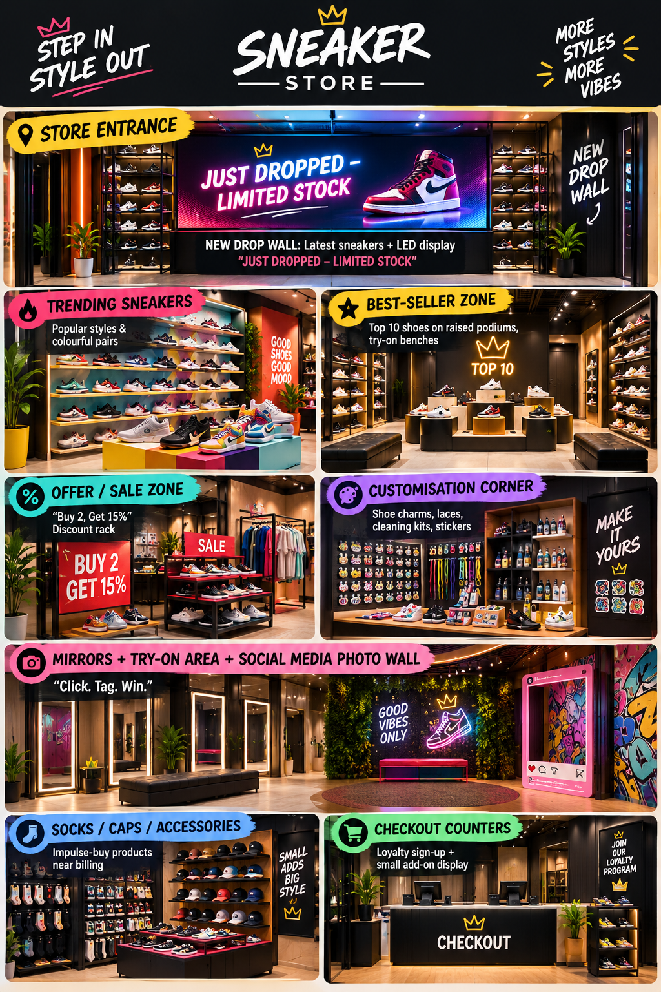

Why this layout works
- Entrance par New Drop Wall: Customer enter karte hi latest aur limited-edition sneakers dekhega. Curiosity aur urgency create hogi.
- Centre mein Best Sellers: Sabse popular shoes ko middle zone mein rakhne se maximum footfall milega.
- Try-on area: Comfortable benches, mirrors aur good lighting customer ko shoes try karne ke liye encourage karegi.
- Photo wall: Gen Z customers Instagram reels/photos ke liye attractive background use kar sakte hain; free social-media promotion milega.
- Checkout ke paas accessories: Socks, shoe cleaner, laces aur caps low-price add-ons hain; billing ke time impulse purchase ho sakta hai.
- Offer zone: Discount rack ko visible but slightly inside rakhenge, taaki customer store ke aur sections bhi dekhe.

3. Soft-drink launch announcement/jingle
New soft drink name: FizzUp
“Hey students, lecture ke baad energy low?
Try karo naya FizzUp—thanda, fizzy aur full refreshment flow!
Canteen mein aaj sirf ₹20 mein first sip special!
Ek sip lo, group ke saath chill karo, aur boring break ko fun banao.
FizzUp ke saath har break banega full-on fresh!
Abhi canteen counter par jao aur bolo—‘Ek FizzUp, mood up!’”

4. Instagram retail-brand analysis
Brand chosen: Decathlon India
Maine Decathlon se related recent Instagram promotions observe kiye. In campaigns mein social media ka use karke logon ko physical stores visit karne ke liye encourage kiya gaya.
Campaign / Event | Description | Physical-store footfall kaise badhta hai

Campaign / Event | Description | Physical-store footfall kaise badhta hai
Decathlon Sports Utsav 2026 | Sports Utsav ko 23–24 May ke liye 135 stores, 56 cities aur 600+ events ke across promote kiya gaya. Customers ko games, sports participation aur prizes ka attraction diya gaya. instagram | Normal shopping trip ek activity/event experience ban jaati hai. Families, students aur sports enthusiasts store mein aate hain aur event ke baad products browse/purchase bhi kar sakte hain.
50th Anniversary Store Celebration | Decathlon ke 50th anniversary celebration ke time 24–26 July ko in-store events, festive store experience aur up to 50% off promotion kiya gaya. instagram+1 | Limited dates aur discount urgency create karte hain. “Live events” ka element customers ko sirf online shopping ke bajay physical store visit karne ka reason deta hai.
Anniversary Sale with Activities | Decathlon ke earlier anniversary campaign mein best-selling sports gear par discounts, in-store fun events aur prizes highlight kiye gaye the. instagram | Discount shoppers ko attract karta hai, jabki games/prizes families aur young audiences ko entertain karte hain. Store visit ek memorable brand experience ban sakti hai.

Overall analysis
Decathlon ka Instagram content sirf “product kharido” nahi bolta—woh sports participation, community events, rewards aur limited-time sales ko combine karta hai. Isse customers ko physical store visit karne ke multiple reasons milte hain: products try karna, event join karna, prizes jeetna aur limited-time discount lena. Sports Utsav jaise multi-city events especially strong footfall driver hote hain because they turn stores into local sports-activity hubs.

